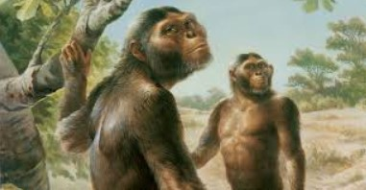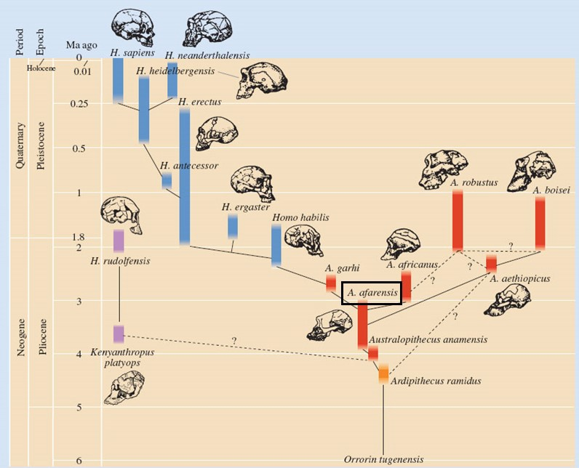

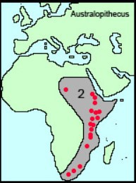

**Relationship to humans:**

* Direct ancestor to humans but also to other extinct hominids, some on other “branches”

**Time Period:**

* 3-4 mya (Pliocene)
* Several species

**Distribution:**

* East Africa

**Climate:**

* Becoming drier:
* Forests becoming grass- land.
* Selection pressure for bi- pedalism and adaptability.

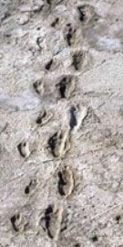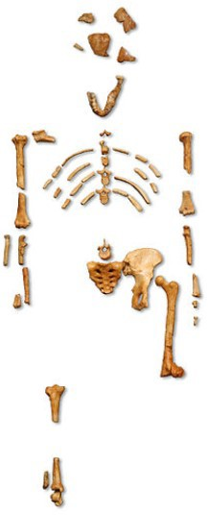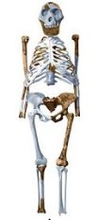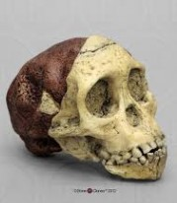

**Fossil Record:**

Laetoli Footprints

* 3.6 mya
* Discovered 1978—Leakey and team
* Evidence of bipedalism
  + Aligned big toe
  + Heel strike, toe off motion

“Lucy” - partial skeleton

* 3.2 mya
* Discovered 1974
* Partial skeleton shows evidence of lifestyle
  + Strong chest and upper arm—climbing
  + Short, broad pelvis—bipedal
  + Limb carrying angle—bipedal
  + Flat nose, prognathic jaw - ape-like

“Taung Child” - skull with endocast

* 2.8 mya
* Discovered 1924—Raymond Dart
* Skull and endocast:
  + Foramen magnum beneath skull— upright stance
  + Endocast shows apelike brain but

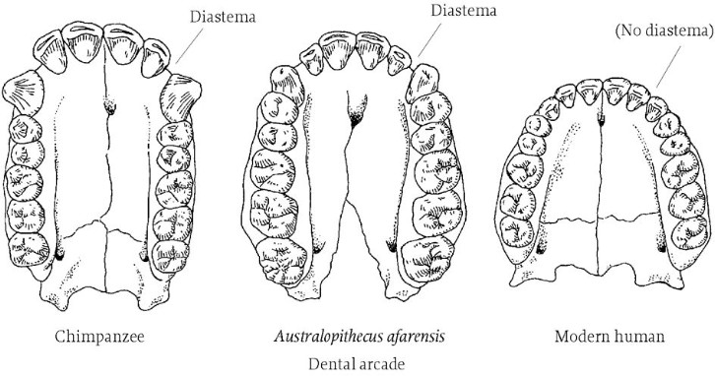

**Lifestyle:**

* In trees and on ground
* Bipedal gait
* Foraging and scavenging
* Family groups

**Diet and Dentition:**

* Mostly fruit, leaves, vegetation
* Teeth intermediate between apes and humans:
  + Rounder jaw than apes
  + Smaller diastema than apes
  + Smaller canines than apes

**Cultural Evolution:**

**Tool Use**

* Used rocks and sticks in foraging eg to “fish” for insects or break nuts—much like chimps today. MAY have crafted primitive stone tools.

**Fire Use**

* No evidence of fire use

**Language, Art, Abstract Thought**

* No evidence of complex Language, art or abstract thought

***Australopithecus***

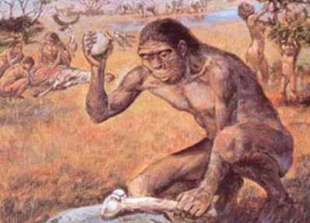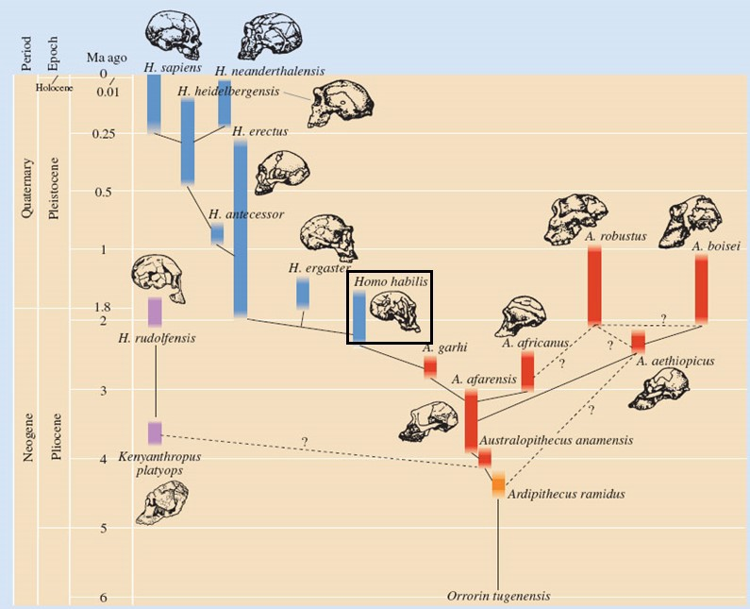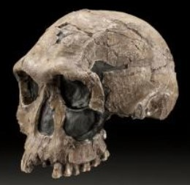

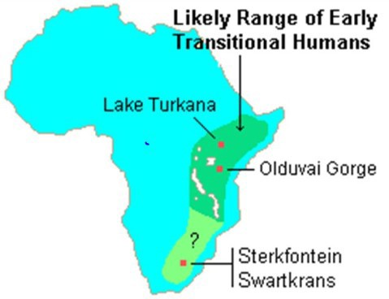

**Relationship to humans:**

* A possible direct ancestor of humans, coexisted with other hominids

**Time Period:**

* 1.5-2.5 mya
* Pleiocene/Pleistocene

**Distribution:**

* East Africa, esp Olduvai

Gorge

**Climate:**

* Spreading grasslands and savannah
* Selection pressure for bi- pedalism and adaptability.

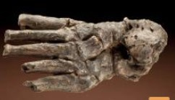

**Fossil Record and what it tells us:**

* Variety of fossil fragments found in various East African locations, including Olduvai Gorge:
  + Foot fragments—aligned toe, arch similar to mod- ern humans—bipedal.
  + Skull—larger cranial capacity than *Australo- pithecus,* smaller brow ridge.
  + Skull fragments—prognathic jaw but less so than

*Australopithecus,* foramen magnum at base— bipedal

* + Hand fragments— large hands, thumb similar to modern chimps
  + Arm fragments—longer arms than modern humans
  + Jaw fragments—dental arcade rounder than *Australopithecus,* teeth smaller.
* Stone tools found, same age as fossils— “Oldowan” Tool Culture

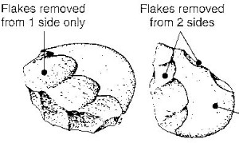

**Cultural Evolution: Tool Use**

* “Olduwan” Tool Culture (may also be *Australopithecine)*
  + Crudely flaked river pebbles
  + Crafted into choppers
  + Large chips—not finely crafted

**Fire Use**

* No evidence of fire use

**Language, Art, Abstract Thought**

* No evidence of complex Language, art or abstract thought

**Built Structures**

* Made shelters from sticks and vegetation
* No evidence of clothing

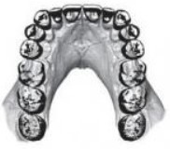

**Lifestyle:**

* In grassland
* Bipedal gait
* Foraging and scavenging
* Family groups
* Made shelters and used tools

**Diet and Dentition:**

* Mostly fruit, leaves, vegetation—some meat.
* Teeth show rounded dental arcade:
  + Tough enamel—cope with vegetation
  + Smaller teeth than *Australopithecus,* but

larger incisors than humans

***Homo habilis***

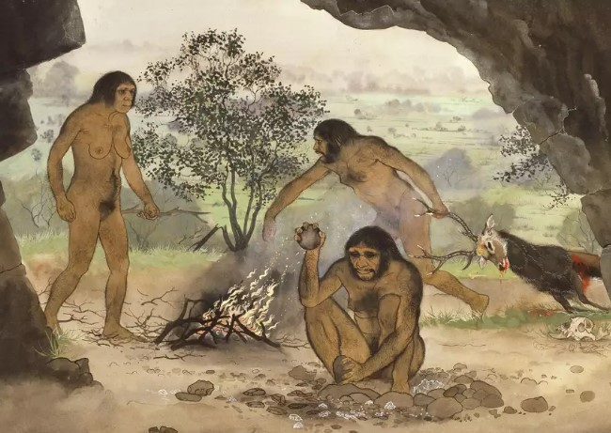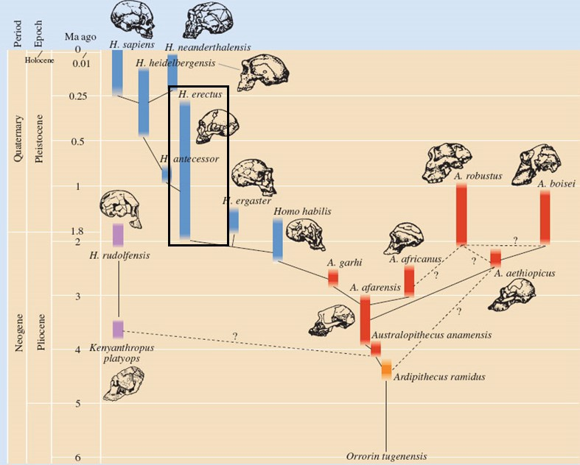

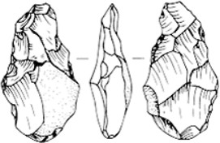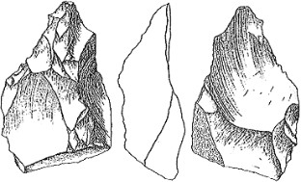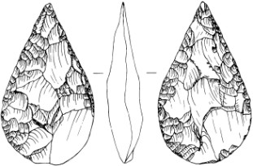

**Language, Art, Abstract Thought**

* Likely to have had some language, but not as complex as modern humans
* No evidence of art or abstract thought.

**Built Structures**

* Made shelters from sticks and vegetation, also used caves.

Evidence of fire use in hunting, and cooking. May have had some control over

fire.

Used to butcher animals.

•

**Fire Use**

•

**Cultural Evolution:**

**Tool Use**

* Made hand-axes “Acheulian”. Finely flaked, bifacial tools—hand axes.

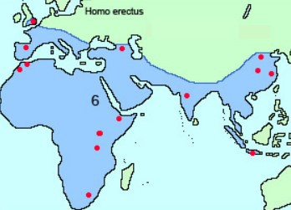

**Relationship to humans:**

* A likely direct ancestor of humans, coexisted with other hominids, evolved into several different

branches.

* Early *H.erectus* in Africa sometimes classified as *H.ergaster*

**Time Period:**

* 150 000 — 2 mya
* Pleistocene

**Distribution:**

* East Africa, migrating out to Asia and Europe

**Climate:**

* Variety of climates across range
* Selection pressure for bi-

pedalism and adaptability.

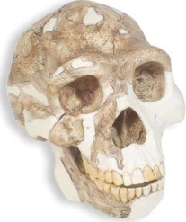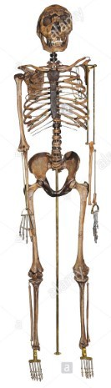

**Fossil Record and what it tells us:**

* Variety of fossils found in Africa, Asia and Europe, including almost full skele- tons show:
  + Shallow pelvis, long legs—efficient bipedal movement
  + Skull—increase in brain size to 1050 cubic cm, similar structure to mod- ern humans.
  + Large brow ridge, thick facial bones, no defined chin, sloping forehead, broad, flat nose.
  + Tooth size decreasing—closer to modern humans
  + Foramen magnum at base of skull—bipedal
  + Limbs similar to modern humans
* Stone tools—more sophisticated than previous species. Fossil record for tools incomplete—may have used bamboo in Asia, which then degraded.

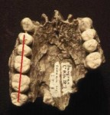

**Lifestyle:**

* Modified environment to suit them
* Bipedal gait
* Family groups
* Made shelters and used tools
* Cared for elderly and disabled
* Planned hunting—eg driving elephants into swamps.

**Diet and Dentition:**

* Large amounts of meat, supplemented with

plant foods.— Allowed for brain development

* Teeth show movement towards parabolic dental arcade:
  + Teeth smaller than previous species.

***Homo erectus***

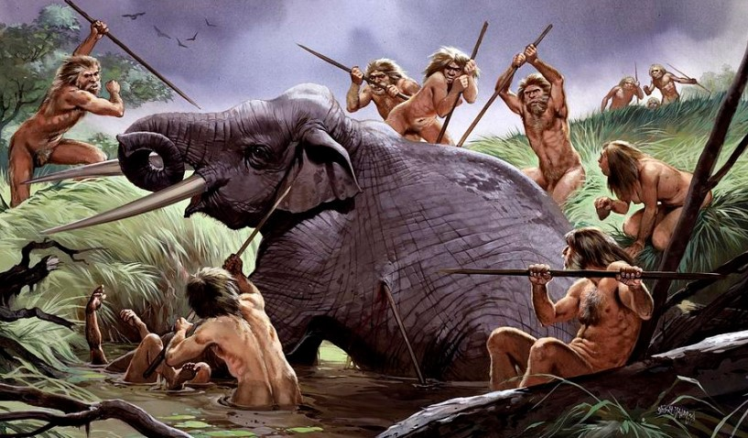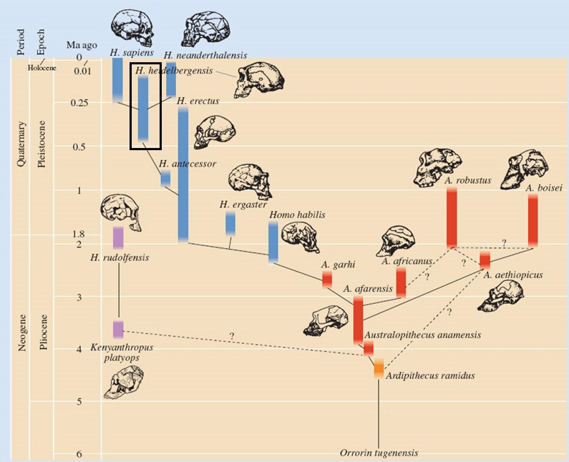

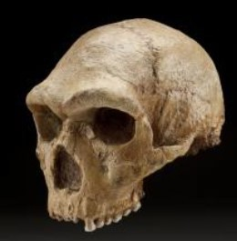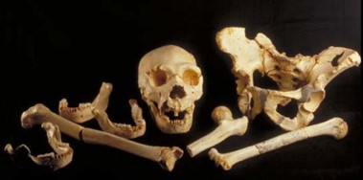

Evidence of hearths showing fire use, and butchery of animals for food.

Stone tools—used Acheulian tools similar to those used by *H. erectus*

•

•

**Fossil Record and what it tells us:**

* Variety of fossils found in Africa and Europe show:
  + Tall and long legged.
  + Stongly built
  + Prominent brow ridges
  + Larger brain than previous species—1250 cc. Frontal and parietal lobe enlargement indicates complexity.
  + Tooth size decreasing—closer to modern humans
  + Face more flattened than previous species.
  + No pointed chin
  + Parabolic dental arcade



**Cultural Evolution: Tool Use**

* Made hand-axes “Acheulian”. Finely flaked, bifacial tool. Used for chopping , cutting.
* Wooden spears for hunting

**Fire Use**

* Evidence of fire use in hunting, and cooking. Likely able to make and control fire

**Language, Art, Abstract Thought**

* Likely to have had language, growing in complexity
* No evidence of art or abstract thought, but evidence of some ability to plan.

**Built Structures**

* Made shelters

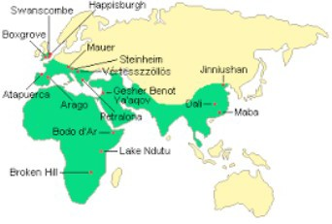

**Relationship to humans:**

* Direct ancestor of humans, also of Neanderthals

**Time Period:**

* 200 000—700 000 years ago—Pleistocene

**Distribution:**

* East Africa, migrating out to Europe and part of Asia

**Climate:**

* Earth moving into an ice age. Low sea levels al-

lowed movement across land bridges

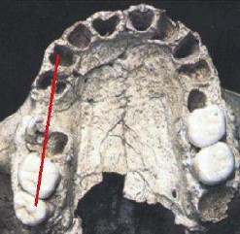

**Lifestyle:**

* Modified environment to suit them
* Bipedal gait
* Family groups
* Made shelters and used tools
* Cared for elderly and disabled
* Planned hunting including spearing large herd animals.

**Diet and Dentition:**

* Large amounts of meat, supplemented with plant foods.— Allowed for brain development
* Teeth show movement towards parabolic dental

arcade:

* + Teeth smaller than previous species.

***Homo heidelbergensis***

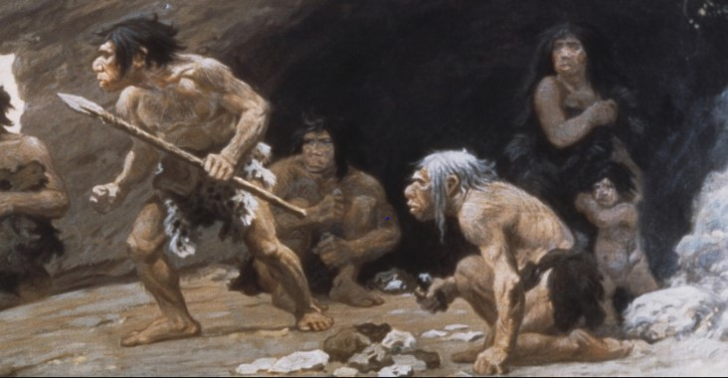

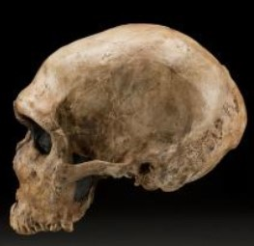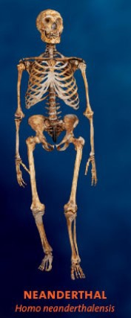

Evidence of hearths showing fire use, and butchery of animals for food, and

wearing of skins as clothing.

Stone tools—used complex stone tools

•

•

**Fossil Record and what it tells us:**

* Variety of fossils found in Europe show:
  + Shorter, more robust and muscular than modern humans
  + Stongly built
  + Prominent brow ridges
  + Brain similar size to modern humans.
  + Long, low skull, rounded brain case
  + Occipital bun—strong neck muscle attachment
  + Some jaw projection
  + No pointed chin
  + Large nose
  + Teeth larger than modern humans

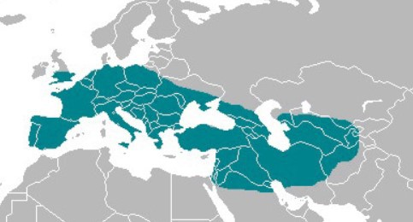

**Relationship to humans:**

* Common ancestor with humans.
* Evolved from geograph- ically isolated population of *H. heidelbergensis*
* Coexisted with humans, some interbreeding

**Time Period:**

* 40 000—400 000 years ago

**Distribution:**

* Ice-age Europe and Central Asia.

**Climate:**

* Ice –age Europe.
* Cold, glaciated

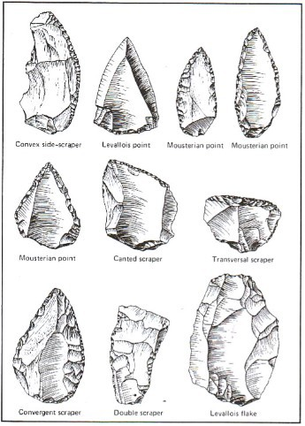

**Cultural Evolution: Tool Use**

* “Mousterian” industry—used stone core and flaked off and refined a range of tools

**Fire Use**

* Evidence of fire use in hunting, and cooking. Able to make and control fire

**Language, Art, Abstract Thought**

* Likely to have had language, growing in complexity
* Some evidence of burial of dead
* Little evidence of art or adornment

**Built Structures**

* Used caves but also made shelters

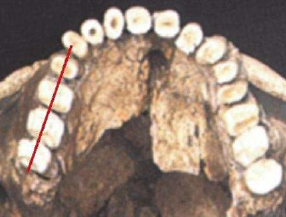

**Lifestyle:**

* Modified environment to suit them
* Bipedal gait
* Family groups
* Made shelters and used tools
* Cared for elderly and disabled
* Planned hunting—ambush of large animals

**Diet and Dentition:**

* Large amounts of meat, supplemented with plant foods.
* Teeth larger than modern humans
* Parabolic dental arcade

***Homo neanderthalensis***

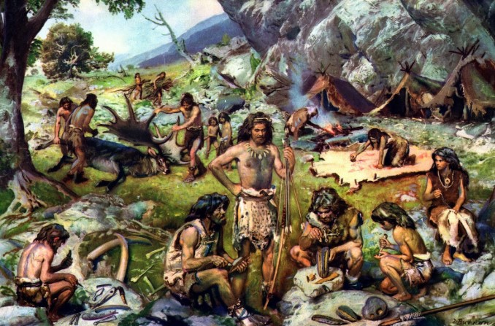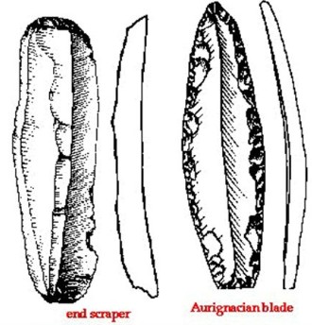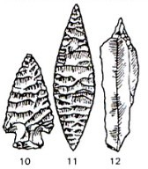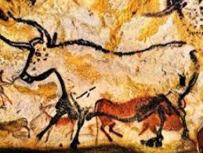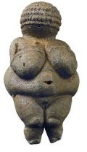

Evidence of art, abstract thought, sewing, jewellery, burial of dead

Evidence of a wide variety of tools and rapidly evolving culture and technology

Evidence of hearths showing fire use, and butchery of animals for food, and

wearing of skins as clothing.

•

•

Physically identical to modern humans

•

•

**Fossil Record and what it tells us:**

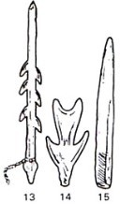

**Cultural Evolution: Tool Use**

* Increasingly developed tools and technology over time: Aurignacian 30-40 thousand years ago
  + Range of tools flaked/chiselled/carved from pre- pared cores
  + Blades and other items Solutrean 20-30 thousand years ago
  + Pressure flaking
  + Finely flaked, leaf shaped blades
  + Included some specialised tools eg fish hooks, sewing needles

Magdelanian 10-20 thousand years ago

* + Stone, bone, antler all used
  + Range of tools including barbed blades

**Fire Use**

* Evidence of fire use in hunting, and cooking. Able to make and control fire

**Language, Art, Abstract Thought**

* Complex burial rituals with grave goods
* Manufacture of jewellery, statues and art

**Built Structures**

* Increasing complexity of built structures.

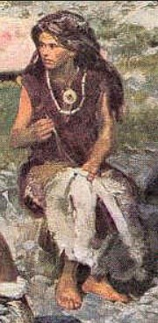

**Lifestyle:**

* Increasing complexity of social structures
* High levels of technology
* Still hunter-gatherer lifestyle
* Emerging religious rituals
* Art, sewing, music

**Diet and Dentition:**

* Meat and plant based diet
* Jaw and teeth as for modern humans

**Relationship to humans:**

* Genetically and physiologi- cally same as modern hu- mans
* Evolved from geograph- ically isolated population of *H. heidelbergensis*

**Time Period:**

* 70 000 years ago towards present.

**Distribution:**

* Africa, spreading into oth- er parts of the world.

**Climate:**

* Ice –age Europe, towards modern day
* Range of climates and locations.

***Early Homo sapiens***

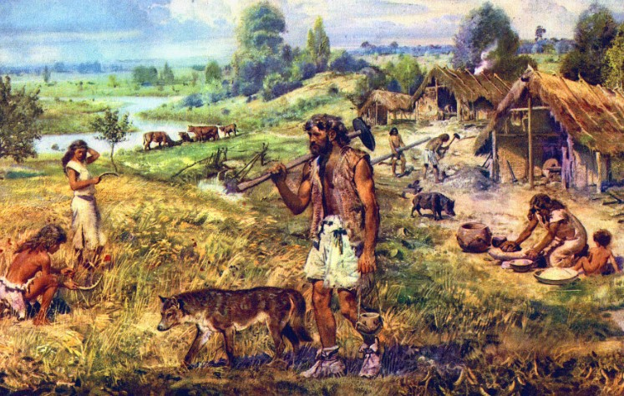

Evidence of rapidly improving tools, agriculture, thought, art and general pro-

gress.

Physically identical to modern humans

•

•

**Fossil Record and what it tells us:**

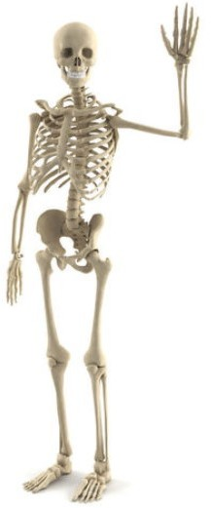

**Cultural Evolution Agricultural Revolution**

* Occurred worldwide at the same time—climate allowed for agriculture
  + Fertile river valleys including in Middle East
  + Allowed grain to be domesticated—better samples selected for re- sowing
  + Animals domesticated
  + Allowed division of labour, and time to think and innovate.

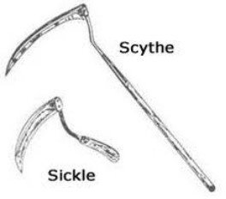

**Lifestyle:**

* Increasing complexity of social structures
* High levels of technology
* Agriculture
* Religion, philosophy, science emerging
* Art, design, engineering, sophisticated language and communication
* Development of weaponry

**Diet and Dentition:**

* Meat and plant based diet
* Jaw and teeth as for modern humans

**Relationship to humans:**

* Genetically and physiologi- cally same as modern hu- mans

**Time Period:**

* 10 000 years ago

(Agricultural Revolution) towards present.

**Distribution:**

* World wide

**Climate:**

* Range of climates and locations.

***Modern Homo sapiens***

# Hominid Evolutionary Trends—Skull and Brain

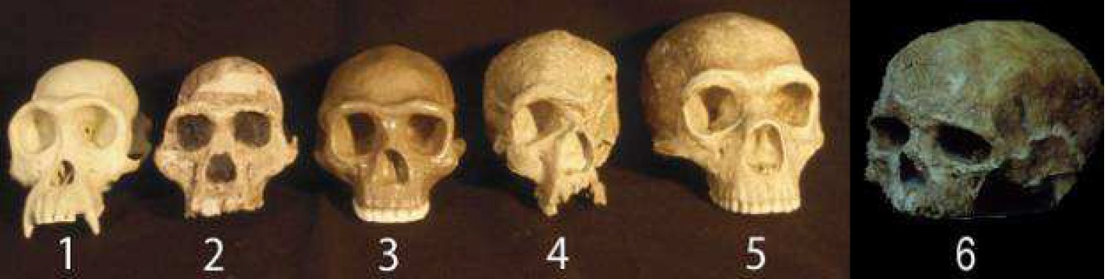

1: Chimp 2. *Australopithecus* 3. *Homo erectus 4. H. heidelbergensis 5. H. neanderthalis 6. Homo sapiens*

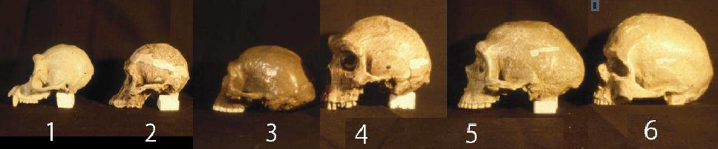

1: Chimp 2. *Australopithecus* 3. *Homo erectus 4. H. heidelbergensis 5. H. neanderthalis 6. Homo sapiens*

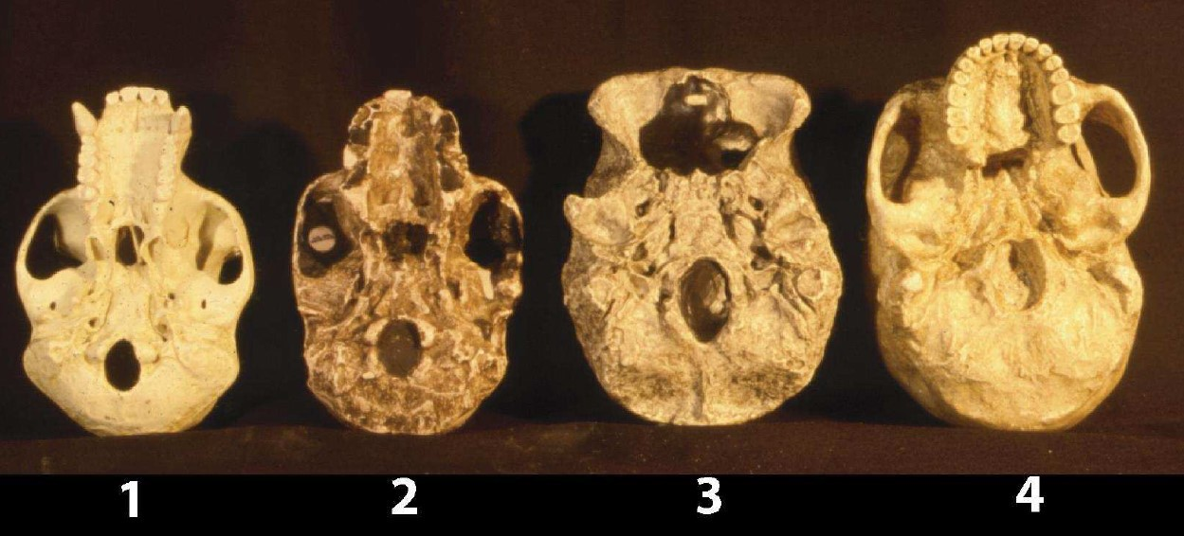

1: Chimp 2. *Australopithecus* 3. *Homo erectus 4. Homo sapiens*

## Trends over time:

* Increasing cranial capacity and brain complexity
  + Occurred in conjunction with greater meat intake
  + Allowed for trends in development of rea-

soning, planning and language

* Decreasing brow ridge size as cranium became larger and more rounded
* Decrease in prognathism (jutting forward) of jaw
  + allowed centre of gravity of skull to be over spine—more efficient bipedalism
* Foramen magnum moving from rear to centre of skull base
  + allowed centre of gravity of skull to be over

spine

* + Allowed forward vision

# Hominid Evolutionary Trends—Dental Arcade, Jaw and Teeth

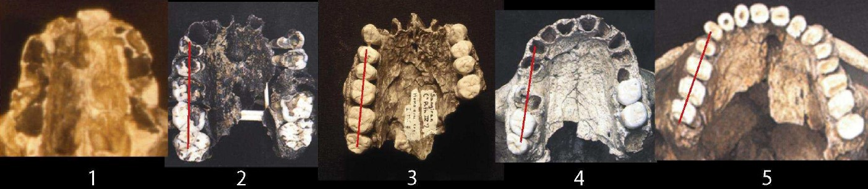

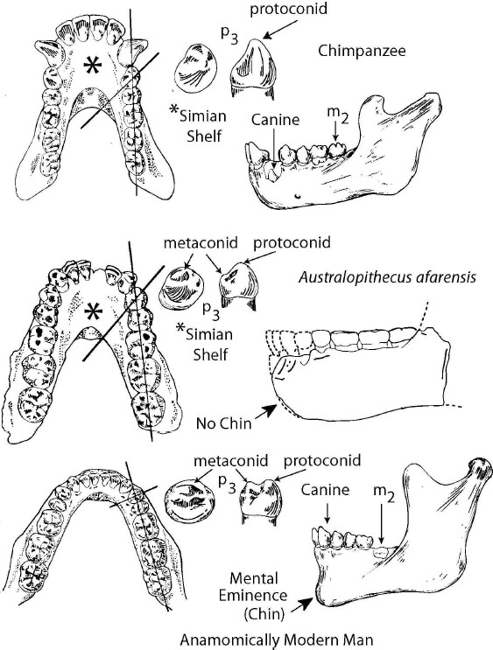1: *Australopithecus 2. Homo habilis 3. Homo erectus 4. H. heidelbergensis 5. H. neanderthalensis*

## Trends over time:

* Dental arcade moving from oblong to parabolic



* Jaw more rounded over time, development of chin
  + Result of changing skull shape—flattening

of face

* Teeth become smaller over time
  + Result of changing skull shape
  + Diet moving from mostly tough plant matter to more meat.

# Hominid Evolutionary Trends— Pelvis, Legs, Feet, Spine

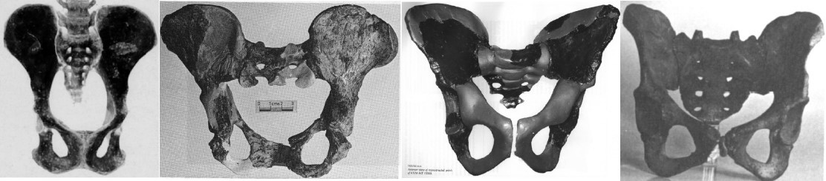

## Trends over time:

* Pelvis shorter and broader, more bowl shaped over time.
  + Supports abdominal organs during upright stance and movement
  + Allows positioning of femurs for upright movement.

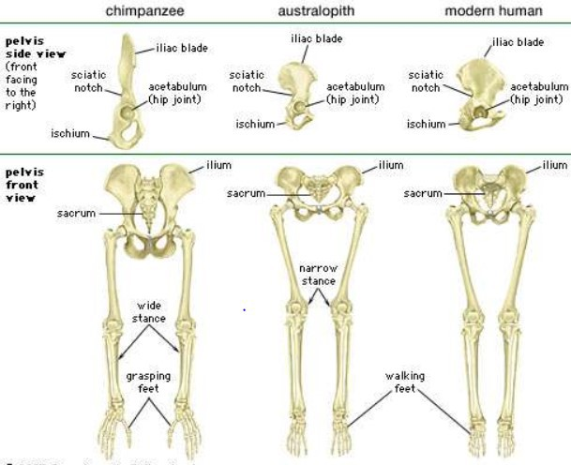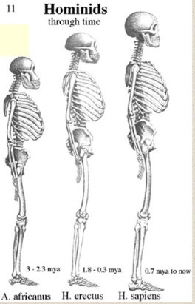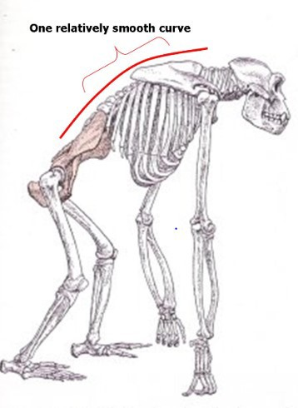

* + Diet moving from mostly tough plant matter to more meat.
* Legs proportionally longer over time
  + Allows longer stride, more efficient biped- al movement
* Femurs angled in towards knees “carrying angle”
  + Allows striding gait, centre of gravity over knees—balance and efficient movement
* Feet decreasing big toe opposability
  + Stability of feet for walking/running
* Increasing foot arches
  + Shock absorption
  + Rolling foot movement for striding
* Movement to S-shaped spine (C shape in chimps)
  + Keeps centre of gravity in line with pelvis and legs.
  + Balances head on top of spine
  + Allows more efficient upright stance— don’t need as many muscles to stand or stay upright.